19 January 2023

Dear Parent/ carer
We have been made aware by West Midlands Police that in the area of Wyrley Birch and Witton Lakes, that backs onto the school there have been in increase in robberies over the last week and in response to that students and parents who walk within the areas may see an increase in police patrols.
Could I ask that all parents remind students of the importance of keeping valuables hidden and not walk along the paths with mobile phones out and ear pods and ear buds on display.
Should you witness or experience any situation in the community that you feel uncomfortable with and believe there is a risk of injury to yourself or another person call 999 when it is safe to do so
Yours faithfully
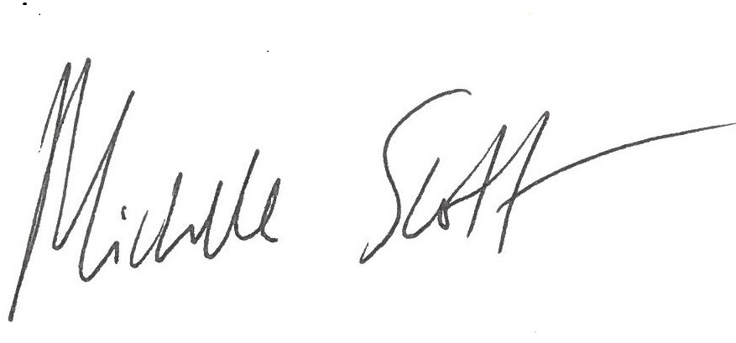
Michelle Scott
Headteacher

