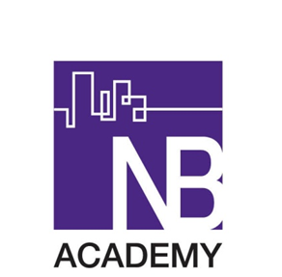

North Birmingham Academy
Consultation Event
Wednesday 12th October

Comment/Feedback Form

Parent/Local Resident/etc | Name (Optional)
Comment/Feedback/Question | Contact Details (if response required)

